MATHS SPECIALIST 3CD SEMESTER 2 2010

EXTENDED PIECE OF WORK #3

Time Allowed: 60 minutes Total Marks: 31

Throughout this investigation you are required to state conclusions with sufficient evidence to justify them.

When writing rules use notations such as: n + 1, F_{n}, f_{n+1}, T_{a+b}, t_{n+2} etc

PART A

Triangle Matrices

The triangle sequence is: | 1 | 3 | 6 | 10 | 15 | 21 | 28 | 36 | 45 | 55 | …
 | t₁ | t₂ | t₃ | t₄ | t₅ | t₆ | t₇ | t₈ | t₉ | t₁₀

In this part you are going to explore triangle matrices.

If t_{n}, t_{n+1}, and t_{n+2} are consecutive triangle numbers then a triangle matrix is defined by

T_{n} = 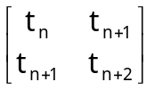

The first five triangle matrices will be:

Using the above definitions, investigate the following. You will need to show some examples to support your conclusions.

1. The addition of two consecutive triangle matrices. [4 marks]

2. The value of the determinant of the triangle matrices [3 marks]

3. The squaring of triangle matrices [4 marks]

4. The product of two consecutive triangle matrices [4 marks]

TOTAL 15 marks
PART B

Fibonacci Matrices

The Fibonacci sequence is: | 0 | 1 | 1 | 2 | 3 | 5 | 8 | 13 | 21 | 34 | 55 | 89 | …
 | f₁ | f₂ | f₃ | f₄ | f₅ | f₆ | f₇ | f₈ | f₉ | f₁₀ | f₁₁ | f₁₂

In this part you are going to explore Fibonacci matrices.

If f_{n}, f_{n+1}, and f_{n+2} are consecutive Fibonacci numbers then a Fibonacci matrix is defined by

F_{n} = 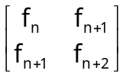

The first five Fibonacci matrices will be:

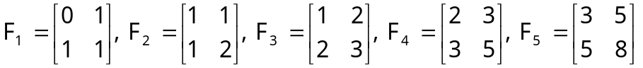

Using the above definitions, investigate the following. You will need to show some examples to support your conclusions.

1. The addition of two consecutive Fibonacci matrices. [3 marks]

2. The product of two consecutive Fibonacci matrices [3 marks]

3. The product of two non-consecutive Fibonacci matrices [3 marks]

4. The value of the determinant of Fibonacci matrices [3 marks]

5. Solutions of simultaneous equations of the form

f_{n}x + f_{n+1}y = f_{m}
f_{n+1}x + f_{n+2}y = f_{m+1}

such that m ≥ n + 1.

eg f₄x + f₅y = f₉ gives 2x + 3y = 21
f₅x + f₆y = f₁₀ 3x + 5y = 34

or

f₆x + f₇y = f₇ gives 5x + 8y = 8
f₇x + f₈y = f₈ 8x + 13y = 13

but not

f₉x + f₁₀y = f₅ gives 21x + 34y = 3
f₁₀x + f₁₁y = f₆ 34x + 55y = 5

[4 marks]

TOTAL 16 marks

